Sanskar Gupta

Story Bible

This is the story bible for the game PASTEL ROM-COM game.

PASTEL

ROM-COM GAME

# INDEX

Basic Story Outline 02

Player Characters 03

Tadano Mugi

Non-Player Characters 04

Yuu Tsukisaki

Tsukasa Tsukisaki

Kazuki Sanmiya

Manami Sakiya

Sayuri Watase

Kiku Murakami

Ken Tadano

Tetsu Shiba

Aoi Sonobe

Mako Minamino

Urara Haruno

Moe Haruno

Pepper

Mikan

Mametarou

Hinako Kayama

Yuu and Tsukasa’smother

Yuu and Tsukasa's father

Yūji Tachibana

Hana Hanayama

Takumi Shijou

Tooko

Settings 15

Tadano Residence

Onomichi High

Tetsu Restaurant

Sakuya residence

Hilltop Rocks

Other Important Narrative Elements 21

Equipment or "Legendary" Items 22

Animals Creatures in the World 23

Historical Lore 23

# Basic Story Outline

16-year-old Mugi Tadano tries to shake off his latest heartbreak by working at his friend's aunt's beach-side inn. One day he spies on a beautiful girl, Yuu Tsukisaki, changing clothes in an alley behind the inn. Instead of getting angry, Yuu charges him the price of a soda for watching her. The next day Mugi is set up on a blind date with Yuu, and they have a great time — until Mugi walks in in the middle of her bath. Yuu decides to leave on the next ferry out, leaving Mugi heartbroken again. However, when he returns home, he is surprised to find that Yuu and her younger sister Tsukasa are going to be his housemates, as their parents were mutual friends.



# 

# Player Characters

Here lies the information about main character of the story i.e. Tadano Mugi which the player is going to play as:

## Tadano Mugi

Mugi is a high school boy who has lived by himself most of his life because of his mother’s death and his father’s being away for work. His friends describe him as plain, yet responsible and dependable. He falls in love with Yuu at first sight, and has fantasies about her after she begins living with him. In order to not compromise their living situation, he suppresses his thoughts, and holds back from

expressing his feelings for her, preferring to just protect her. Despite often stumbling into compromising situations with girls, and having to go along with their demands for his time and attention.

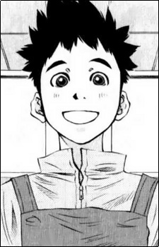

# 

# Non-Player Characters

This section consists of character sketch of all the major and minor characters of the story. Though minor but they too play a great part in Mugi’s life choices.

## Tsukisaki Yuu

The HEROINE of the game and Mugi's love interest, Yuu accepts Mugi's father's offer to live with Mugi after her father dies. She is good-natured, smart and responsible (lacking only some cooking skills and handiwork), described as being very cute with a developed body. She is popular in school and has an easy time making friends. Even though she returns to live with her mother, she later returns to Mugi's place the next summer to finish high school. Although at times she has denied having romantic interest in Mugi, she gets jealous when he receives affections from girls that are not his childhood friends.

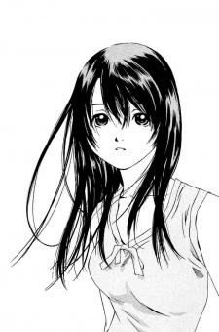

## Tsukisaki Tsukasa

Yuu’s younger sister, Tsukasa is a vibrant, mayhem-causing character who loves attention. She is more knowledgeable about relationships than her older sister, and often embarrasses Mugi by guessing his perverted thoughts, although she herself does not engage in such activity. She sometimes hatches elaborate plans for Yuu and Mugi to be together. She initially lives with Yuu and Mugi, but later moves to live with her mother, and lives in America.

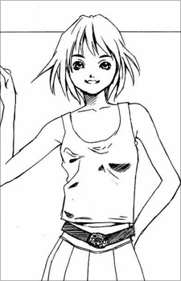

## Sanmiya Kazuki

Mugi’s best friend since childhood. Mugi remarks that he looks about 20 years old. Most girls that he flirts with flatly reject him; those who do not usually slap him because he is too forward. 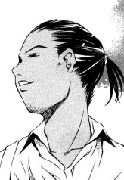

## Sakiya Manami

She is one of Mugi’s childhood friends. She harbors a crush on Mugi, but holds back her confession because he was dating her friend Hinako. She later confesses to Mugi.

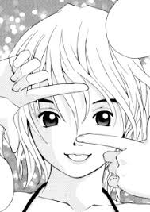

## Watase Sayuri

Mugi’s next-door neighbor who acts like his big sister. After Mugi's mother died, Sayuri watched over him and even taught him how to cook. She is a Tokyo University student and a model. She occasionally visits Mugi where she binges on beer and plays with Tsukasa. She so values her relationship with Mugi that she introduces her fiancé Takumi to him before she does to her parents.

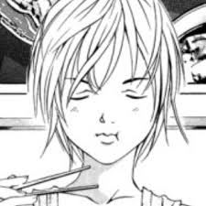

## Murakami Kiku

Kiku is a popular schoolmate that the main characters meet on a group date. She likes to tease guys and use them for her own entertainment, but is piqued when Mugi resists her advances. After seeing how popular and innocent Yuu is, she pretends to be her friend, but secretly tries to sully her reputation by taking scandalous pictures of herself dressed up like Yuu, and spreading them to their choolmates.Well, she is in love with Mugi.

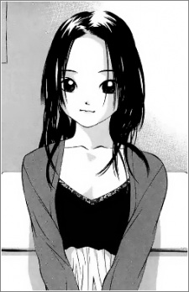

## Tadano Ken

Mugi’s father is a photographer who is often away from home for long periods of time so that Mugi is never sure when he visits. He makes a promise with Yuu and Tsukasa's father that he would take care of his daughters.



## Shiba Tetsu

Tetsu is the owner of a small restaurant; he offers Mugi and Yuu refuge when they get caught in the rain. After tasting Mugi’s cooking, he offers him a part-time job and becomes his cooking mentor. He has an Imari plate collection that dwindles whenever Aoi visits and gets angry. Although Aoi likes him a lot, Tetsu tries not to return her affections because he wants her to be free. He and Aoi often argue., but eventually Tetsu accepts Aoi's feelings, and the two become a couple. When Tetsu was younger, he and Ken were rivals for Mugi's mother's affection.



## Sonobe Aoi

Aoi is a young traveling artist who frequents Tetsu’s restaurant. Although she likes to hug and kiss people, she has feelings for Tetsu, and gets jealous whenever he brushes her off or mentions liking older women.



## Minamino Mako

Mako is a busty woman who joins the Tadano household as Mugi's

new mother. Ken met her in Alaska when he was taking pictures during the Aurora Borealis, where she was mourning the third anniversary of her high school sweetheart’s death. She is a great stepmother who always supports her stepson, Mugi.



## Urara Haruno

Urara is introduced as a schoolmate in Mugi's after-school supplementary class. She has a reputation of being *ero kawaii* (a combination of being erotic but cute) because of her sexy dress and appearance.

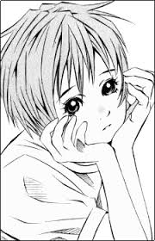

## Haruno Moe

Urara's younger sister who wears glasses. She is described as shy and a bookworm, but well-endowed like her sister. She aspires to be a novelist and solicits Mugi's help to write a story on what it's like to live with Yuu, whom she idolizes. She is a bit airheaded and clumsy, often falling to the floor in a sexy position and losing her glasses.

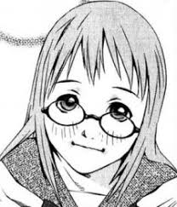

## Pepper

Tsukasa's schoolmate and buddy from America, Pepper is a blonde-haired girl who joins Tsukasa when she returns to Japan. She flirts with Mugi quite a bit when they initially meet. She has a black belt in karate, and also does other martial arts such as judo and aikido.

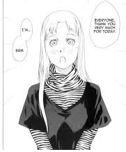

## Mikan

Named after the Mandarin orange box she was found in, Mikan is a kitten that joins the Tadano household.

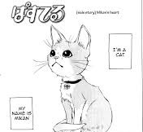

## Mametarou

Yuu's St. Bernard whom she got on her birthday when she was little. He was named after the snack.

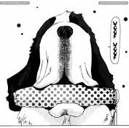

## Kayama Hinako

Manami’s best friend and Mugi's former girlfriend, having broken up with Mugi prior to the start of the series when she left for Tokyo for school. She is very accident prone, and compatible with Mugi and his supportive personality. During Mugi's trip to Tokyo, it is revealed that she still has feelings for him.

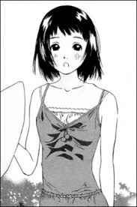

## Yuu and Tsukasa’s Mother

She divorced her husband when her daughters were still in elementary school because she could not handle the long period of time in which he was away. When she remarried, she let Yuu and Tsukasa live with the Tadanos so as to not cause conflict with her new family. After taking Yuu and Tsukasa back, she reconciles with her second husband as her stepson has moved out of the house; she and Tsukasa relocate with her husband to the United States.

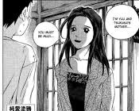

## Yuu and Tsukasa’s Father

A former rival photographer and friend of Ken Tadano. Both were in members of the photography club in university. Because he was away for long periods of time from his family, he and his wife divorced when Yuu and Tsukasa were in elementary school. However, he later retires to take care of his daughters.

## Tachibana Yuji

A good-looking and popular schoolmate who asks Yuu out early in the series. Although Yuu agrees to go out with him, she only thinks of him as a friend. His father owns a restaurant that does French cuisine. (Well if you are not careful enough, Yuu might come to like him.)

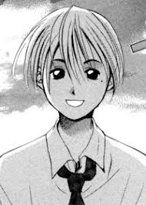

## Hanayama Hana

A daughter of one of Tetsu’s friends who owns a restaurant. Mugi works for her for a week, after which Mugi discovers she is a year younger in his school. Yuu is jealous of her because Hana acts quite friendly with Mugi, walking with him to school and bringing him lunch.

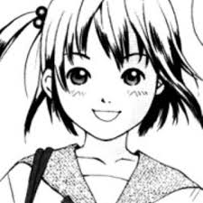

## Shijou Takumi

He is introduced as Sayuri’s fiancé. He works at a small second-hand furniture shop.

## Tooko

Tooko is a young actress from the agency that Sayuri works with. She introduces herself as Mugi’s younger sister, and uses a wig to disguise herself.

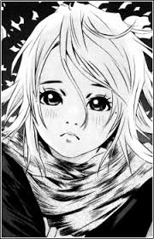

# Settings

The story of the game revolves around a small town named Onomichi where at a hilltop lied a very old house of Tadano Mugi where he lived with his father Tadano Ken. As Mugi’s father is a wanderer photographer, he is usually at different places of world at different places and so Mugi was usually alone.

## Tadano Residence (Living Room)

A place at the home where all the members of the family gather together to have fun and eat delicious food made by our aspiring chef, Mugi.

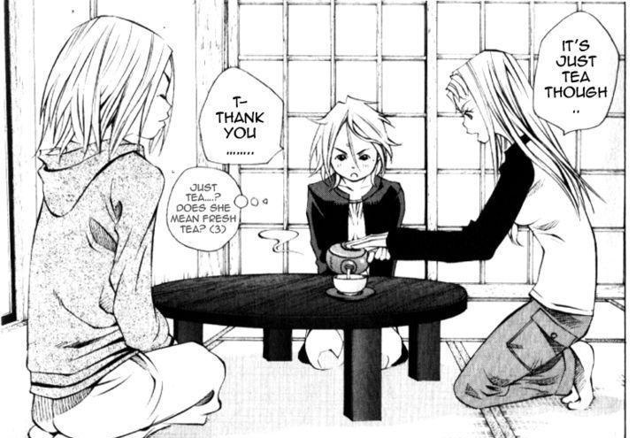

## Tadano Residence (Roof)

This is a place in the house that holds a special place in Yuu’s heart where whenever dejected she and Mugi rest together to talk and share problems.

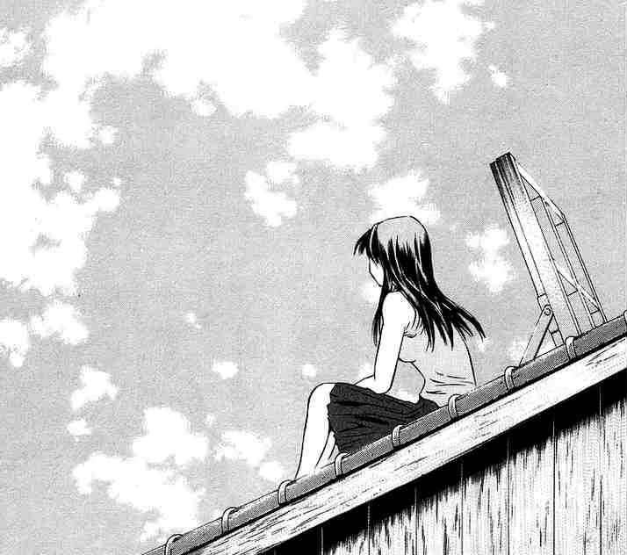

## Tadano Residence (Kitchen)

The place where our protagonist cooks delicious meals for the family members. (for kitchen!!!?? Don’t ask me!Ask Yuu!!!)

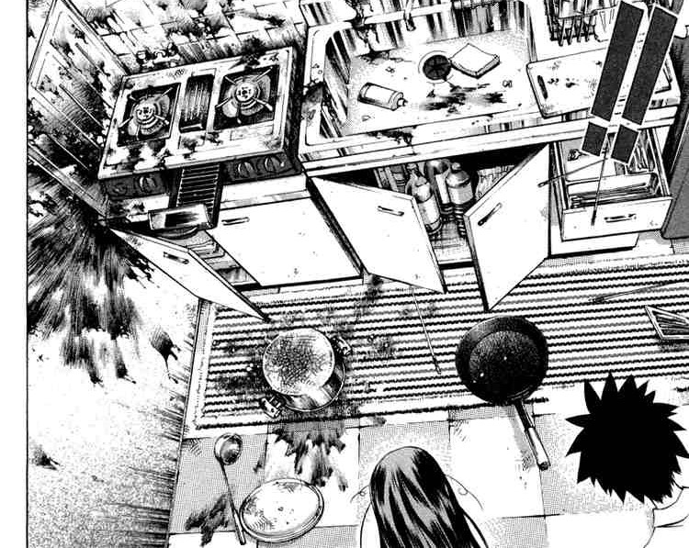

## Tadano Residence (Bathroom)

Place where Yuu and other Female members of the home talk about their love affairs. There are times when there’s an accident and our innocent Mugi barges in to help, though he is hit hard by Yuu afterwards.

## Onomichi High School

A place where everything is done except studying. The place whose corridors were full of fights and breakups whenever Yuu passes through.

## Tetsu’s Restaurant

Mugi works as a part-timer here. Place where everyone gathers to celebrate.

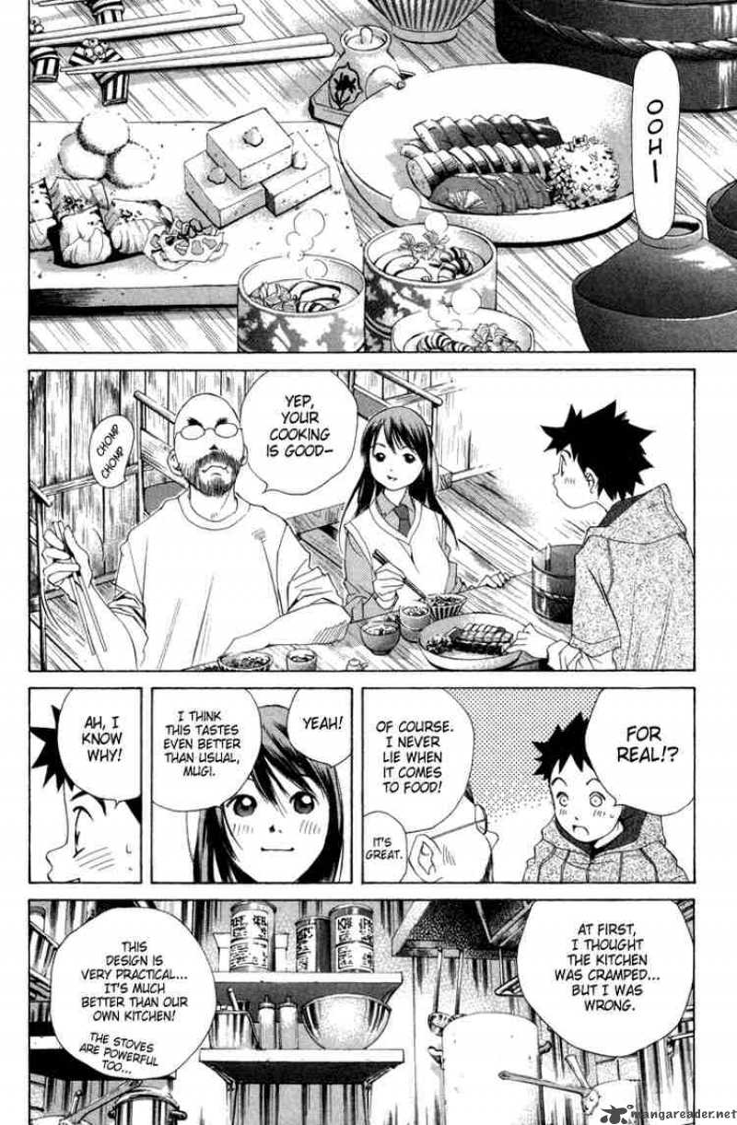

## Sakiya Residence

A normal house of our normally cute Manami-chan.

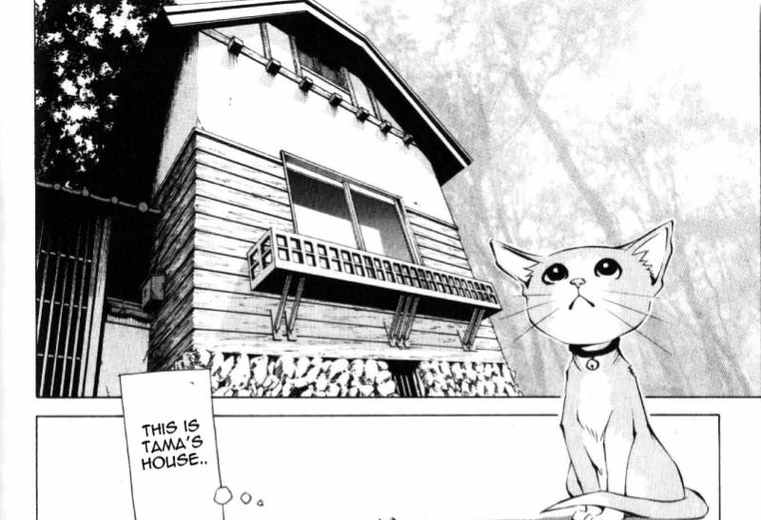

## Beach House

Home to Kazuki’s aunt where Mugi works part-time during summers and also the most special place where Mugi first met Yuu.

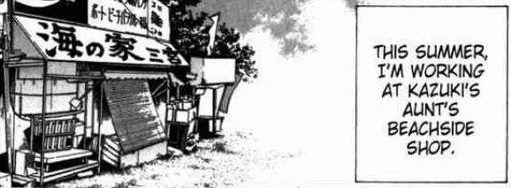

## The Hilltop Rocks

A lover’s point for our protagonist and his Girlfriend. The place with the best view of all of Onomichi.

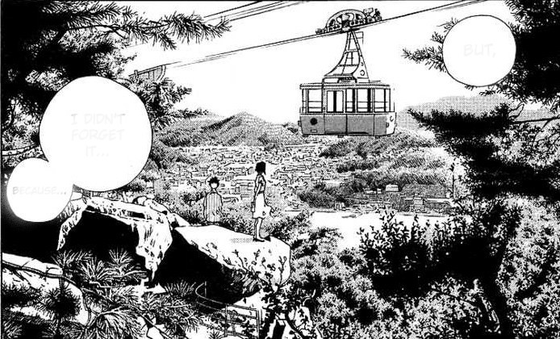

# Other Important Narrative Elements

* CAT GATHERING: You can often find the special meeting of the characters’ cats where they talk about their owner’s love affairs and how they are coward for playing lovey-dovey instead of just mating like other animals. The player can find this meeting occurring at any random scene of the game. (Well, it’s the cats’ choice!!)
* While inside school, while talking to your favorite girl, you can sometimes see a random couple have a fight. Why? Because girls often get jealous, when they see their boyfriend ogling our player’s favorite girl. Really, Mugi is so lucky.
* Players can often find a Ramen or crepe stand while meeting their favorite girl outside and treat them to gain some happiness points.
* If at school, player need not worry about the extra happiness points due to ramen or crepe stands not being there as they can always find a vending machine during school scenes. Well, every school in Japan have to have some VENDING MACHINES.

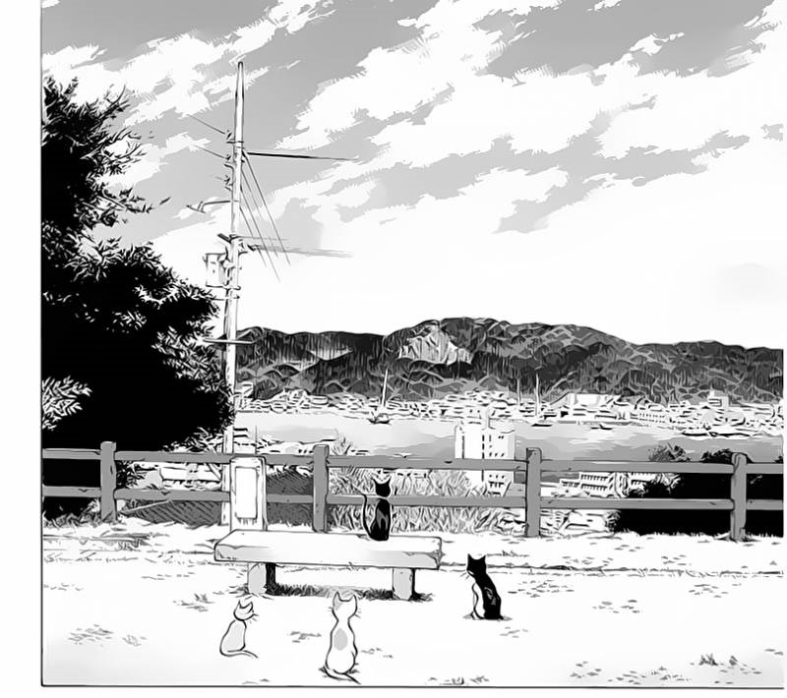

## Equipment or "Legendary" Items

Every girl in this ROMCOM game has their own preferences of gifts and its been taken care of. REMEMBER!! Every girl loves gifts.

## Bouquet of Flowers

Well every girl loves flowers and their fragrance. Mugi(Player) can find flower shop to buy some beautiful flowers for his own heroine.

## Pendant

Though costly, they can earn you a great amount of happiness points from your favorite girl. But, one thing is important, the player has to has reached a certain level of intimacy in order to get his girl accept such costly gifts.

## Movie Tickets

Player can also buy movie tickets in order to fix a Date with his favorite girl. This is a wonderful gift because it gets Player a chance to interact with the girl properly and alone and they can either increase or decrease their points in the heart of their favorite girl.

## Onsen Resort Tickets

A bold and huge step to increase a players chance with their favorite girl. The onsen resort offers a great chance to its players to confess their love to their favorite girls and get them be your GIRLFRIEND. Again, a certain intimacy level is necessary for this setting.

## 

## Animals Creatures in the World

* Mikan: Yuu’s pet cat
* Mametarou: Yuu’s pet dog
* Venus: Kiku’s pet cat
* Tama: Manami’s pet cat
* Kurogane: Kazuki’s pet cat

## 

## Historical Lore

The game world is completely based on a town in Japan named Onomichi where Mugi lives with his father in an old house at a hilltop. His father is usually travelling abroad due to his profession(photographer).

One scene is situated in a park of Tokyo where Mugi meets his ex-girlfriend Hinako where they remember their old fun times of childhood.

The beach house of Kazuki’s is yet another special location in the game because this is the place where he met the game heroine.